CS 255 System Design Document Template

UML Diagrams

UML Use Case Diagram

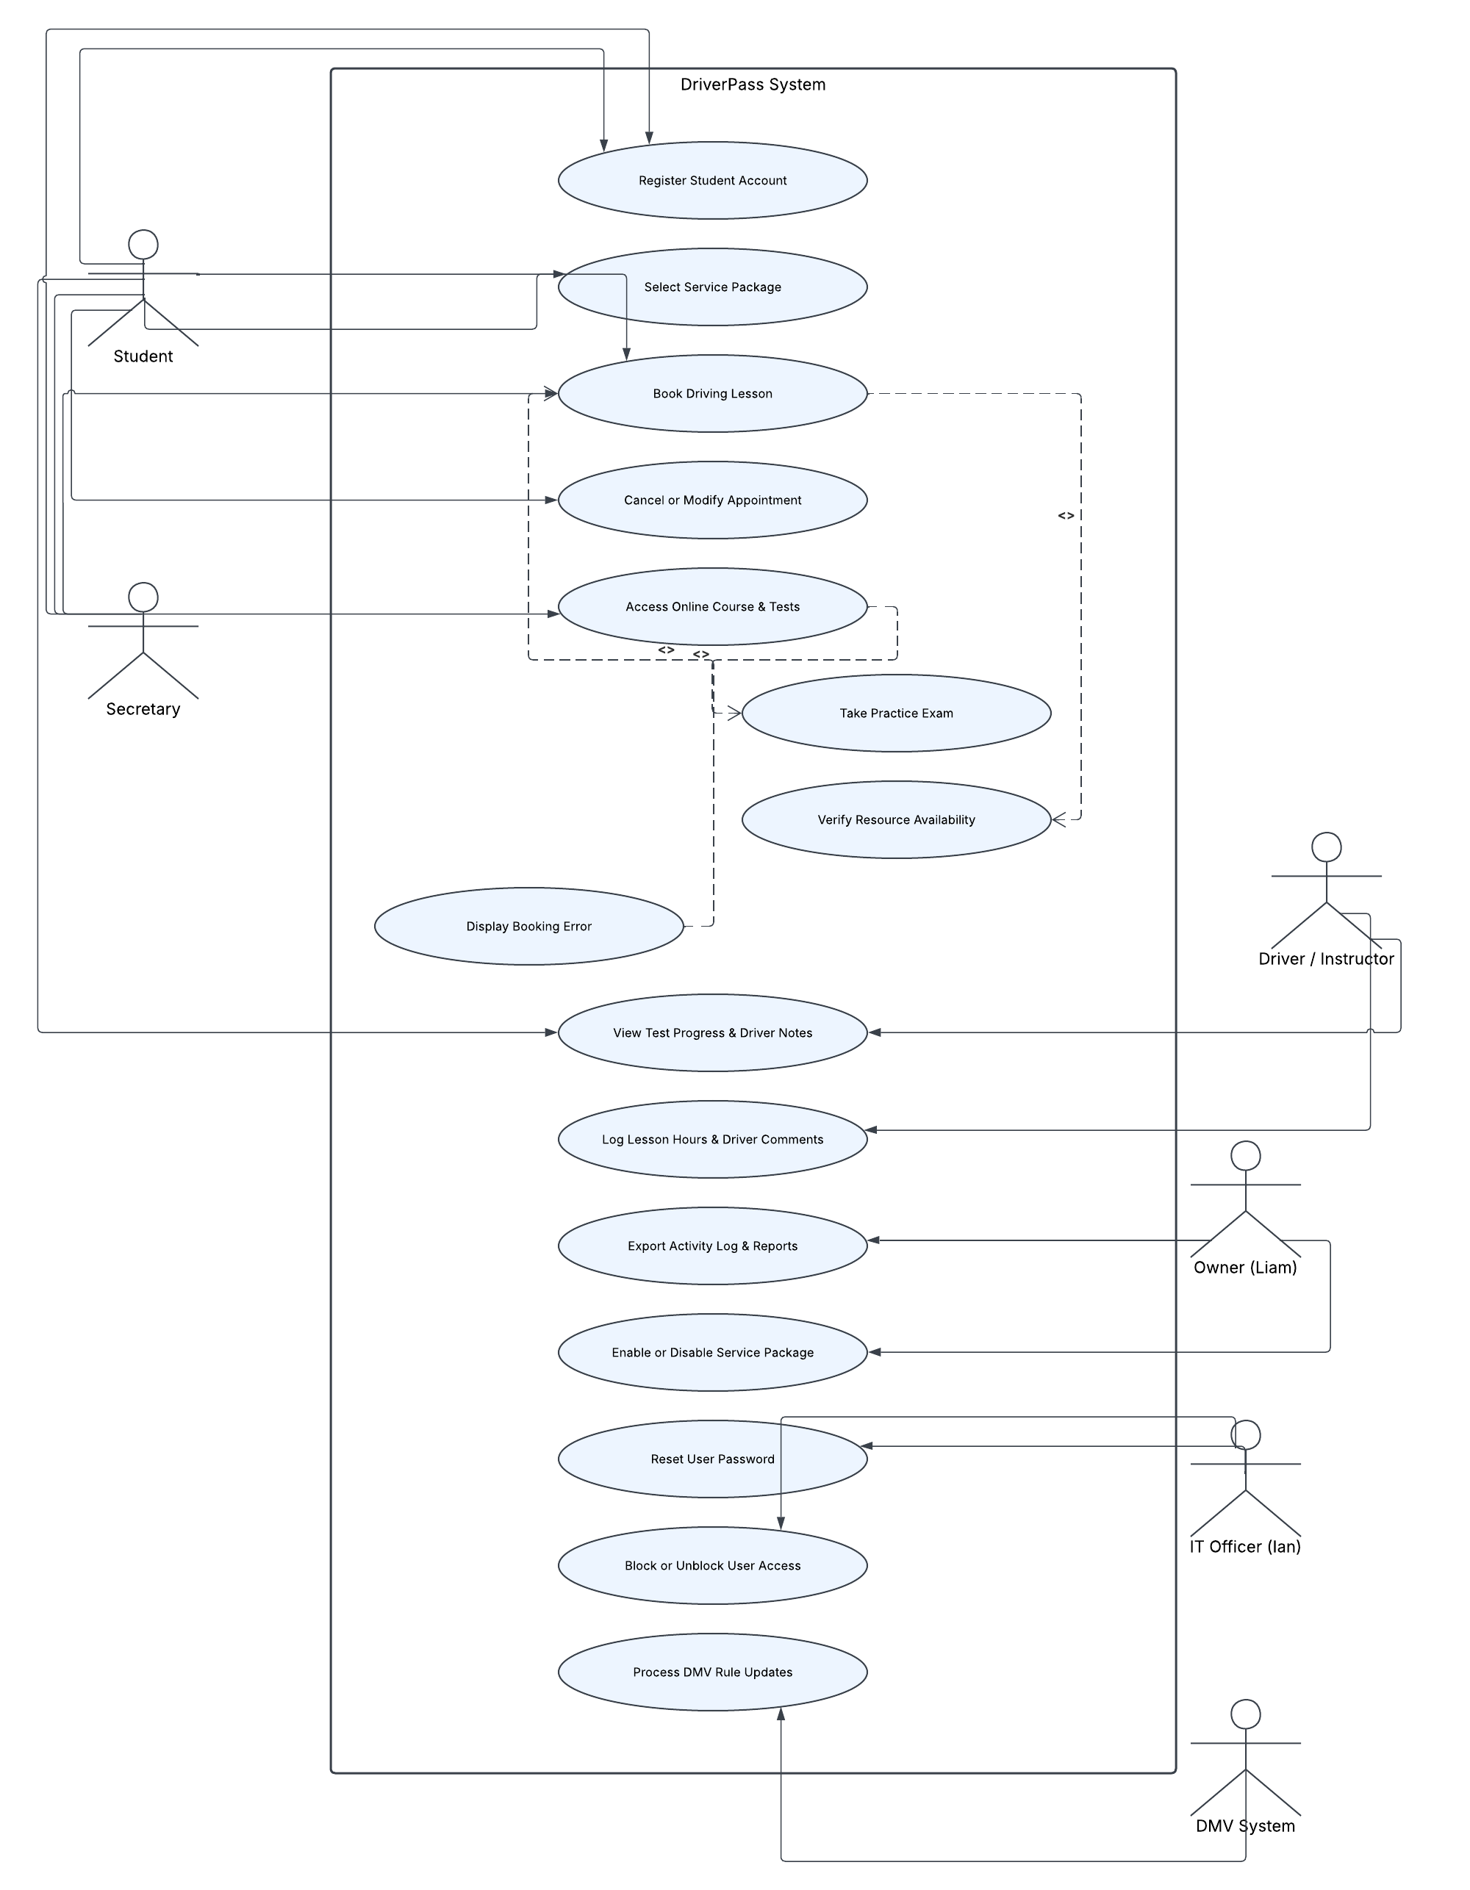

UML Activity Diagrams
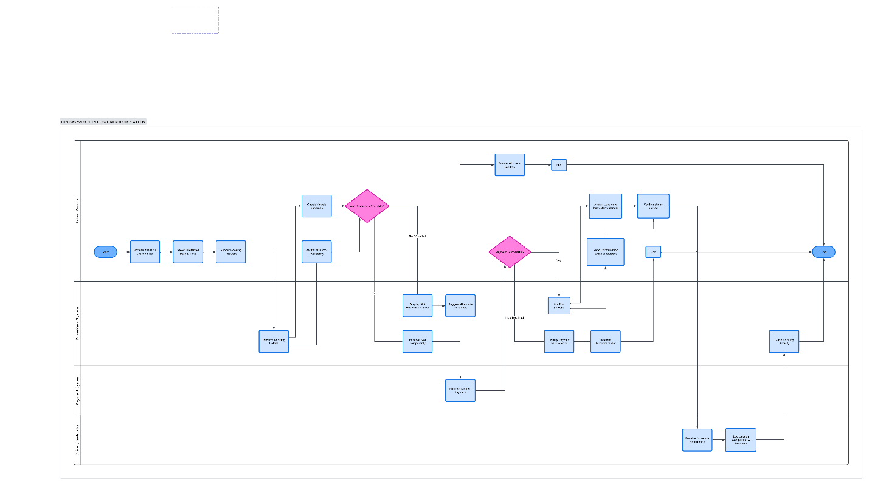
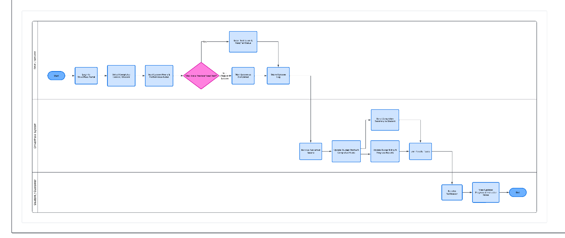

UML Sequence Diagram
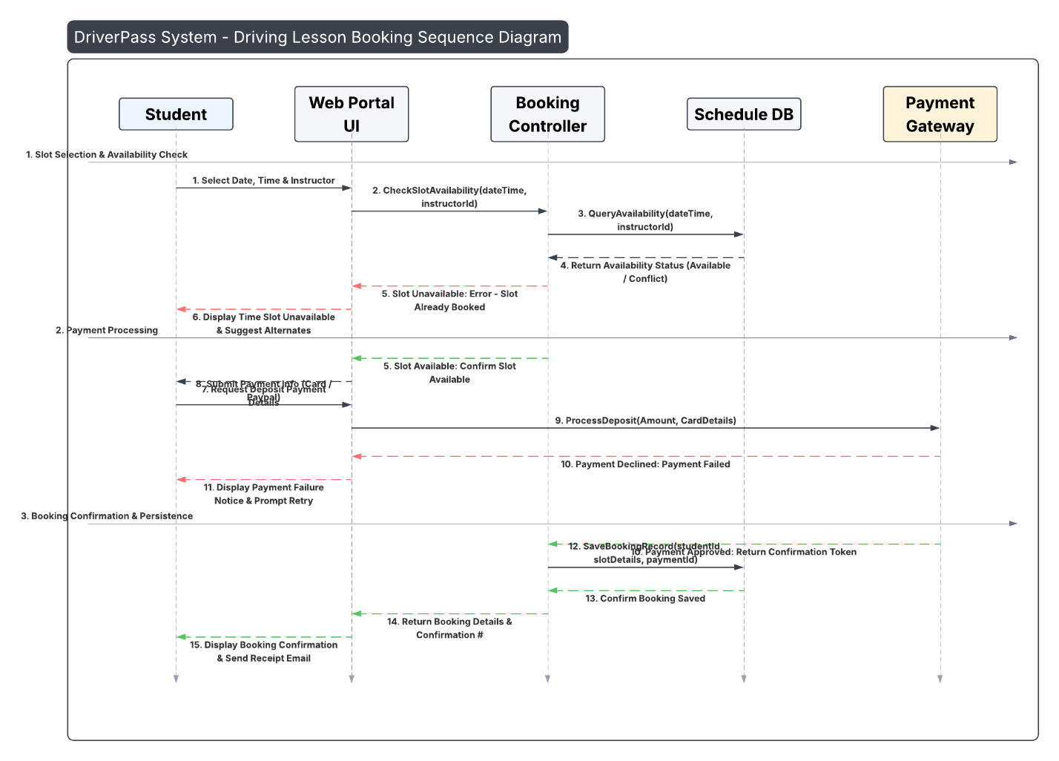

UML Class Diagram
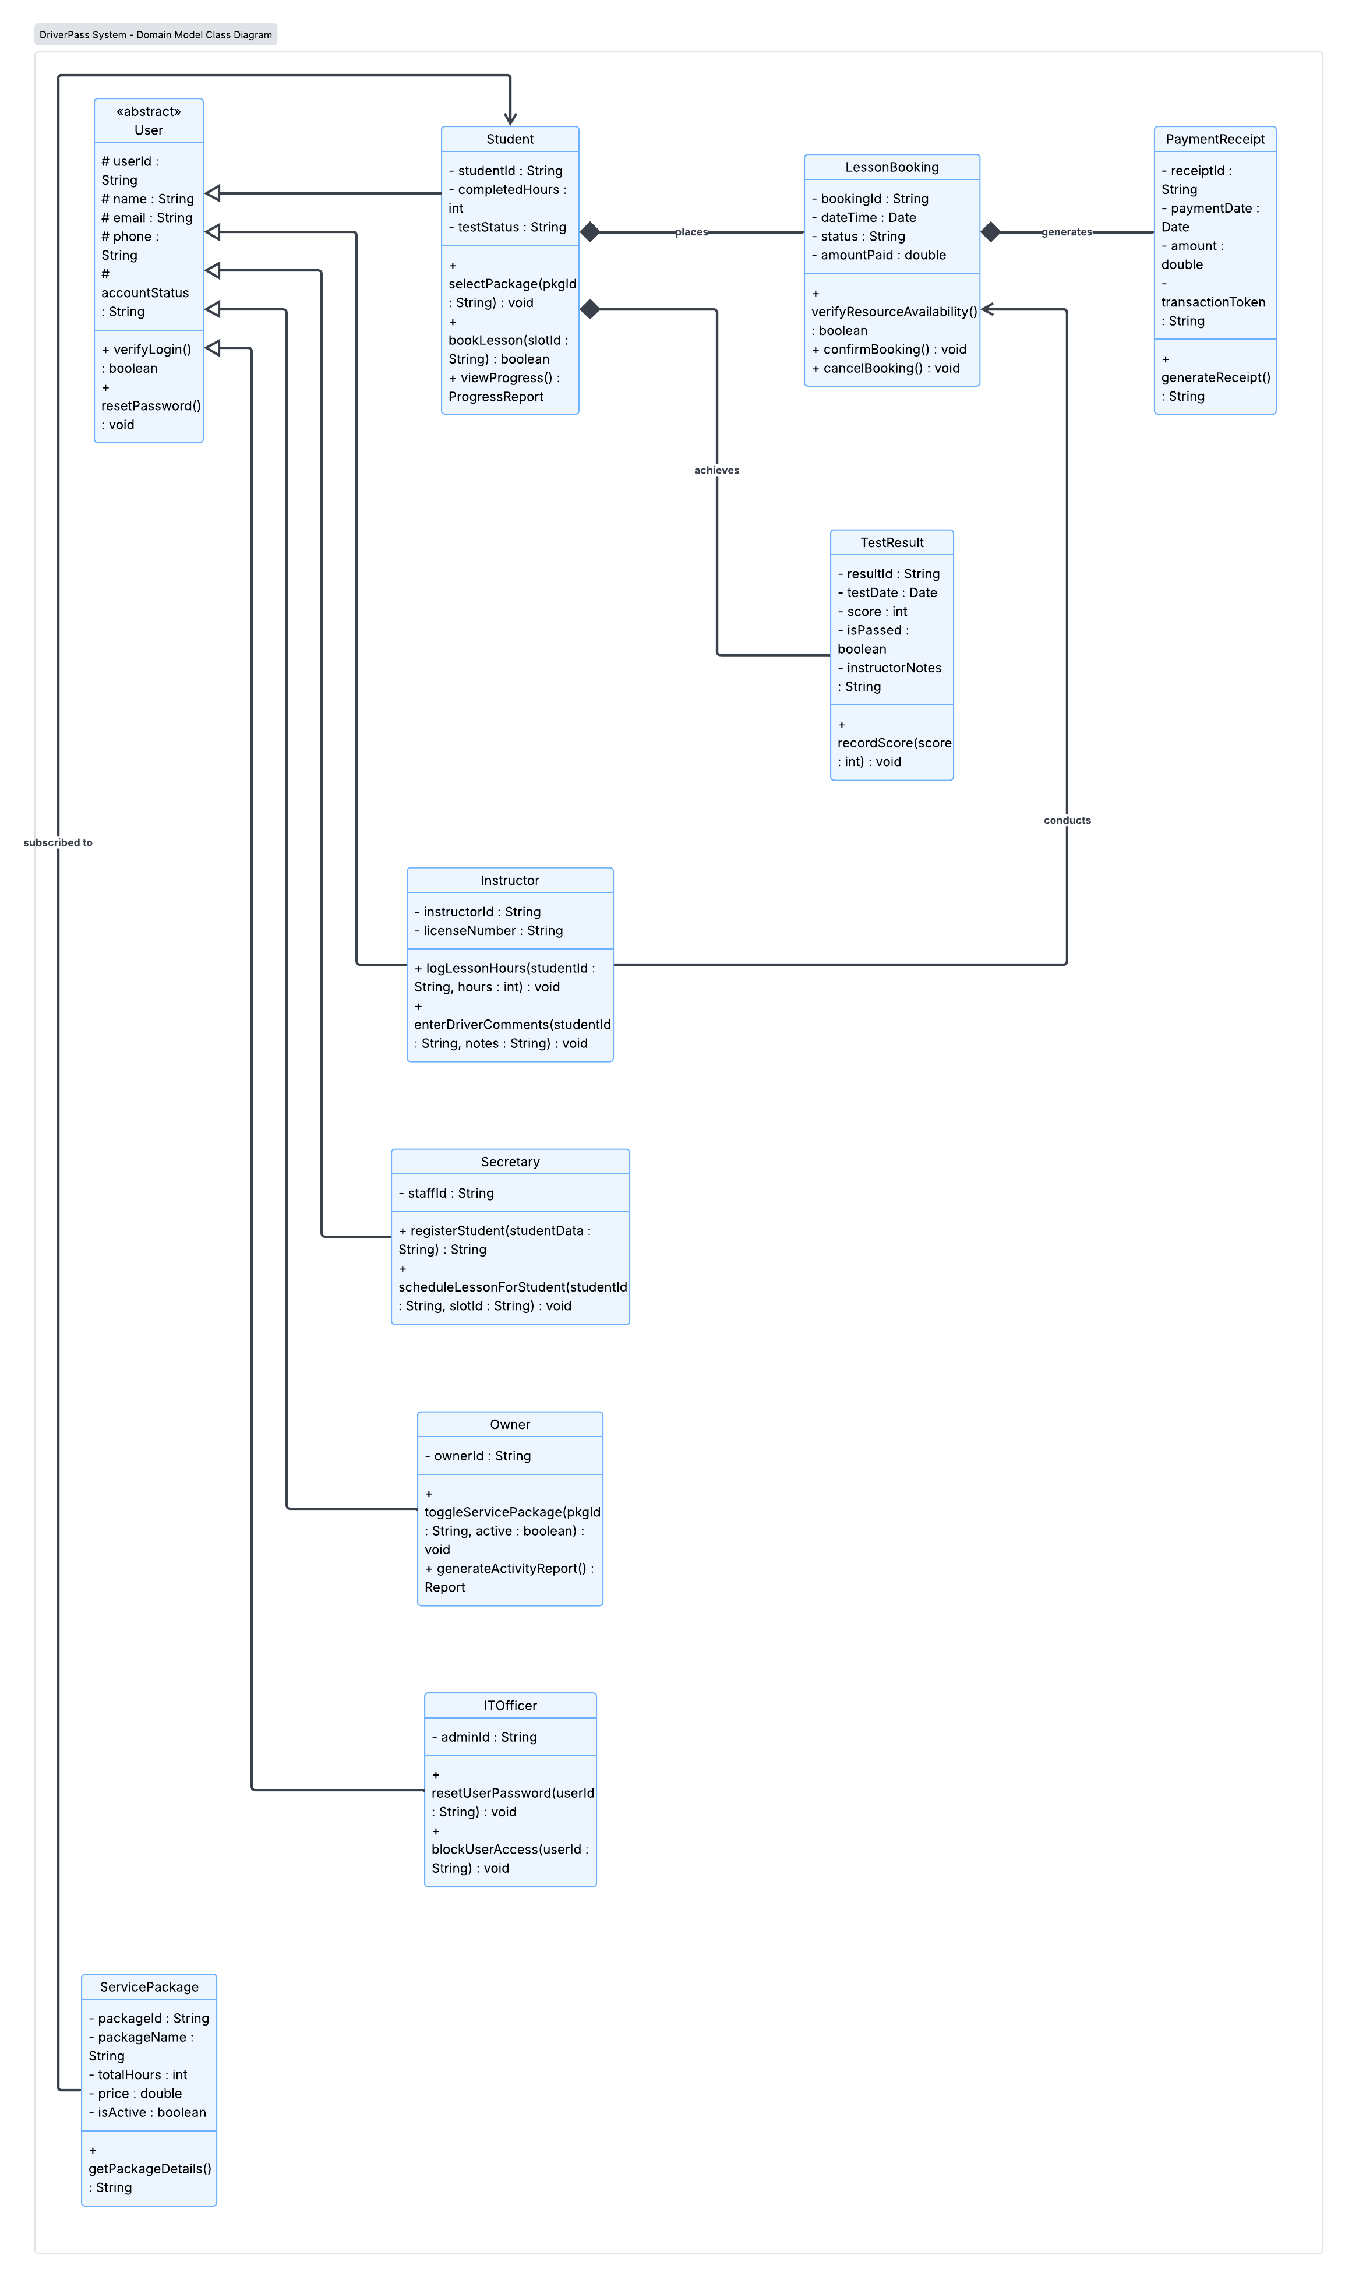

Technical Requirements
1. Hardware Requirements
- User Devices (Client-Side)
  - Students & Customers: Smart phones, tablets, or computer laptops with an internet connection. These allow students to easily visit the website or mobile app to view schedules, buy driving packages, and book lessons from home or on the go.
  - Instructors & Staff: Portable mobile devices or tablets with mobile data/Wi-Fi. Instructors need these in the driving vehicles so they can log student driving hours and enter lesson feedback in real time.
  - Administrative Staff (Secretary, Owner, IT Officer): Standard office desktop computers equipped with monitors, keyboards, and printers. Office staff use these to manage student enrollments, print receipts, view financial reports, and manage user accounts.
- Server Infrastructure (Server-Side)
  - Application Servers: Powerful central computers that run the DriverPass system logic. They handle requests sent from the web app or mobile app, such as searching for open lesson slots or submitting a booking.
  - Database Servers: High-speed storage servers dedicated to saving all the system's data securely. They store user profiles, payment history, and schedule availability, ensuring information can be read and updated quickly without losing data.
2. Software Requirements
- Client & Front-End Software
  - Web & Mobile Interfaces: A clean, easy-to-use web application and mobile app designed for popular web browsers (Chrome, Safari, Firefox) and mobile platforms (iOS, Android). This gives users a smooth interface to book lessons and check their progress.
- Backend Application Software
  - Application Framework: The behind-the-scenes programming framework (such as Java Spring Boot or Node.js) that powers the system's rules. It processes requests from the user interface, coordinates with the database, and handles tasks like booking calculations.
  - Database Management System (DBMS): Software (like PostgreSQL or MySQL) that organizes and protects system records. It ensures that two students cannot accidentally book the same lesson slot at the exact same time.
- External API Integrations
  - Payment Gateway API: A secure connection to payment services like Stripe or PayPal. This allows students to pay for lessons safely with credit cards or online payments without storing sensitive card details on our own servers.
  - Notification Services: Automated messaging software (like Twilio or SendGrid) that automatically sends confirmation emails and SMS text reminders when a lesson is booked, canceled, or updated.
3. Tool Requirements
- System Design & Documentation Tools
  - Diagramming Software (Lucidchart): Used to design, view, and update our system blueprints, including Use Case, Activity, Sequence, and Class diagrams.
  - Version Control (Git / GitHub): A tool that tracks changes made to the application's source code, allowing developers to collaborate safely and keep track of updates.
- Development & Build Tools
  - Integrated Development Environment (IDE): Software like Visual Studio Code or IntelliJ IDEA that developers use to write, test, and debug code efficiently.
  - API Testing Tools (Postman): A tool used to test and ensure that the backend application and external services (like the payment system) communicate smoothly and without errors.
4. Infrastructure & Deployment Requirements
- Cloud Hosting & Scalability
  - Cloud Service Provider: Hosting the system on cloud platforms like AWS, Google Cloud, or Azure. Cloud hosting allows the system to automatically scale up its computer power during busy hours (e.g., when many students log in at once to book slots) and scale down when traffic is low.
- Networking & Security Infrastructure
  - Data Encryption (TLS/HTTPS): Encrypts all data sent between user devices and the server, keeping personal information and passwords safe from hackers.
  - Role-Based Access Control (RBAC) & Authentication: Ensures that users only see what they are allowed to see. For instance, a Student can only view their own bookings, while an Owner can view overall business financial reports.
  - Payment Compliance (PCI-DSS): Following strict industry security standards for processing payments so user financial data remains protected.
- Backup & System Monitoring
  - Automated Data Backups: Automatically creates daily backups of all database records so that information can be restored quickly if an unexpected technical issue occurs.
  - System Monitoring & Logging: Tools that keep track of system health, alerting administrators if the system slows down or encounters errors so issues can be fixed immediately.

